Role of Human Resource and The Organization of the Human Resource Function.
Human resource management basically focuses on shaping the organization’s workforce to toil the main objectives at maximum potentiality. Over the years, Human Resource has been undermined and criticized for exhibiting a ‘managerial’ alignment, restraining the voice of the employee and ethical considerations (Wooten 2001). However, today Human Resource is one of the demanding departments required in sustaining the development of any organization.
The department of Human resource has a premeditated breakdown of roles, that define its unique purpose and give it originality. To start with Human Resource are mandated in finding and recruiting the right people for a specific task. So many factors are in to play when looking for specificity. Other screens include reviewing individual’s personality, which sometimes becomes very strenuous and expensive.
Secondly, human resource establishes the organizational culture and environment in which individuals like employees, to have the capability, apprehension, and assurance of serving customers well. The department acts as an advocate of the employees.
Professional development is always stirred by the human resource, with the sole purpose of getting the right skills needed by the organization in achieving its objectives. Employees from time to time are enrolled to conferences that end up shaping them into dependable managers of tomorrow.
Another dominant role, is work compliancy. Human resource managers are one of the few dockets that ensure the organization is functioning in accordance to the laws and regulations of labor and employment. Without this, employees are prone to unfairness, unhealthy work safety measures among other demoralizing and unfavorable factors.
Human resource function is mainly divided into three groups: Front Office, Back Office and Center of Excellence. The Front Office human resource function is concerned by direct contact or the first approach with clients or consumers. Its responsibility is to ensure, the organization’s introduction to clients is proficient enough. The office is very vital and could affect how every other function works. However, the Front Office is entirely dependent to the back office for support and administration.
Back Office on the other hand, acts as the backbone of all the other Human resource functions. The traditional HR administrative roles are mostly found within the back office margins. Activities like payroll and welfare amenities are fall under the office. The office is responsible for keeping individuals’ files, records and data that is regularly updated.
Lastly the Center of Excellence. This office is independent when it comes to its functions. It takes part in recruitments, training, professional development, compensation, industrial relations among others. It functions partially with the front and the back offices in maximizing the potential of employees within the organization.
The strategic impact of human resource management, defines purposes and campaigns related to the inclusive organizational deliberations, such as organizational effectiveness, and to more specific aspects of people management, such as, resourcing, learning and development, reward and employee relations. According to Purcell (1999), strategic impact of HR is what we see as competitive advantage or impotence of an organization in the market.
In the past, business leaders viewed human resource specialists as the professionals that ensure that all staff members comply with organizational policies. The role of the human resource specialists has also typically been associated with administrative duties, such as gathering, filing and storing paperwork, and enforcing company regulations. Today, organizations are in desperate search of HRM’s who will contributes to the development of and the accomplishment of the organization’s wide business plan and objectives. The objectives of HR are established to support the attainment of the overall strategic business plan and objectives. As a HR professional, my skills are to an extent aligned with the business, my personnel component of the organization is categorized as a strategic partner to business success by default.
Huselid, Becker and Beatty (2005) affirmed that the features in the HR Scorecard are key leading indicators for workforce success. This method positions transparency of progress across the organization. Basically the HR scorecard will accurately measure the impact of all HR policies on firm performance and capture the full impact of HR. However, how detailed and sophisticated the score card is, the more the information captured, hence more accurate.The conceptualized structure of a common score card should include the following defining lagging measures from the leading measures at each stage.
Strategy; this docket pin points leaderships skills at disposal, organization integration, capabilities and talent as well as the impact of culture in the organization. The second element is operations which include optimizing workforce and service delivery. The other element is customer; where one focuses on engagement index, customer friendly costs among other third party influences. Finally, the finances; these showcases the productivity of the company financially, giving a clear projection of profits, stakeholders and internal costs.

Example of a detailed HR Scorecard.
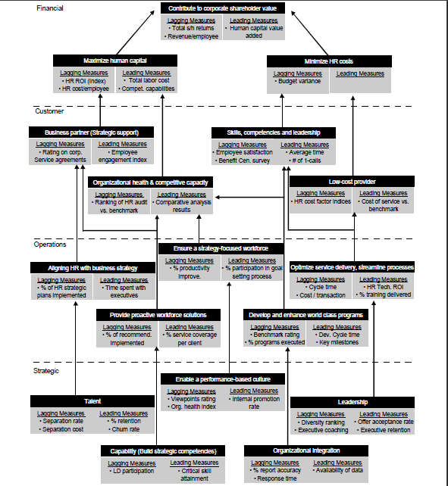
Recognition/Rewards (Either Formal or Informal).
From my little experience, I believe a productive workforce is entitled to appreciation, not just their monthly salaries or increments. In this presentation, we will have a different view and understanding of rewarding. As a HR one should be in contact with your employees lives outside their daily jobs. One gets to know them better and have a stable view of their personality. Having such vital information, rewarding becomes need-specific and more tangible than the normal rewarding we are used to. For example, you could notice one of your employees has a broken handset, he/she is trying to replace it at the end of the month. If coincidentally, the person is the employee of the month, the reward should be the handset. Such gestures reveal a sense of belonging, where the employee feels genuinely appreciated for their good work. The theme is better in managing resources and HR systems to the maximum, since evaluation is deep and employee oriented. The motivation behind such policies could have tremendous positive impact on the business performance.
Employee Communications.
Every bit of progress within an organization, is achieved through an effective communication system, that incorporates casual workers to the executive officers. Diminishing productivity and faint focus, is one of the simple barriers that can be eliminated through communication among employees. One of the sidelined improvements that can kick start such objectives is restructuring office premises, into units under one roof. The team work presence builds stronger workplace relationships thus increase productivity and reduce amounts of employee turnover, call outs and poor customer service skills.
With proper communication platform, where functions are direct and clear, resources can be utilized effectively. Most of them will be shared within the premises with a sole purpose of enhancing morale and team building.
How HR Functions.
Human Resource function revolve around the following duties; hiring and recruiting (primary function), training and development, compensations, benefits, relations and legal responsibilities. It goes without saying that HR are the agents of change when it comes to how organizations operate. Management of HR resources in executing functions will certainly determine the outcome.
Enhancing Your HR Utilization and Understanding.
Enhancing utilization and understanding in HR, comes with a lot of responsibility and aggressiveness in the attempt of maximizing efficiency of the organization. One has to learn how the system works better that anybody else and have a divergent outlook of functions across all boards. These will narrow down the valid decisions to make and allocate the adequate resources at any given stage. The HR scorecard is one of the implements that could help monitor the achievable goals step by step with greater understanding of functions.
Major Insight or surprises from the class that deepened your understanding to Human Resources in general
My major surprise was how dependable the HR office is, and its effect on the general performance of the organization at large. I often thought HR was a tool meant for the interviews and compensation. Learning the diversity of the HR functions is an eye opener, sensitizing the importance of Human Resource Department in any given business or organization, no matter how small?

References
Purcell, J. (1999) Journal; Research in Personnel and Human Resources Management. Pg. 12.
Wooten, K.C. (2001) Book; Human Resource Management Review. Vol 11, No 1–2. Pp159–75.
Huselid, Becker and Beatty (2005) Article Review; Linking People, Strategy and Performance. Pg. 7.

